Requirements
Specification
for
CSV Library
Requirements for Version 1.0
Prepared by Dawson De Mond

Table of Contents
1.Introduction 4
1.1 Purpose 4
1.2 Scope 4
1.3 Intended Audience 4
2.Overall Description 4
2.1 Major Functions 4
2.2 Assumptions and Dependencies 4
3.Specific Requirements 5
3.1 Functional Requirements 5
3.2 Non-Functional Requirements 6
3.3 Performance Requirements 7
3.4 Hardware Requirements 7
3.4.1 User Requirements 7
3.5 Error Recovery / Handling 7
4. User Interface Design 8
4.1 Common Interface 8
4.2 Reading Interface 8
4.3 Writing Interface 8
5. Appendices 8
5.1 Finite-State-Machine for Strict Reading 8
5.2 RFC 4180 CSV Format Specifications 9

Revision History
Name | Date | Reason For Changes | Version

1.Introduction

1.1 Purpose
The purpose of this document is to specify the requirements for the CSV Library.

1.2 Scope
The CSV Library will provide an easy-to-use API for reading and writing CSV files in Java.

1.3 Intended Audience
The intended audience for the CSV Library includes:
- Java Programmers
- Data Scientists
- Scholars & Professors

2.Overall Description

2.1 Major Functions
Below is a list of the major functions or features the CSV Library will provide.
- Reading CSV files (strict or unstrict – more on that below)
- Writing to CSV files

2.2 Assumptions and Dependencies
- Dependencies
  - Requires Java 24 or higher.
  - Uses standard Java libraries, no external dependencies.
- Assumptions
  - Users have basic knowledge of CSV files and their format.
  - Users have basic knowledge of working with Java Collections and Strings.
  - Users and designers (i.e., of this library) understand what an RFC is.

3.Specific Requirements
This section describes the functional and non-functional requirements of the CSV Library.
Note regarding requirements:
- CRFL (\r\n) or carriage return and line feed, was used to move a cursor to the beginning of a new line on systems. Nowadays, some systems may or may not support CRFL (e.g., just using \n) such as some Linux systems. These requirements will state CRFL but refer to a system-dependent line separator. For example, Java provides a system-dependent line separator string that returns the correct CRFL – the CSV Library must satisfy the system-dependent requirement.

- The requirements for writing CSV files are much richer than the requirements for reading CSV files. This decision was in part due to the lack of uniformity surrounding the format of a CSV file. To compensate for this, a strict option is provided, which when enabled, reads a CSV file compliant to RFC 4180 (i.e., see section 5.2).

3.1 Functional Requirements
ID | Description | Priority
FRQ-1 | The CSV library shall provide reading all records of a CSV file. | High
FRQ-2 | The CSV library shall provide reading the next record of a CSV file. | High
FRQ-3 | The CSV library shall provide a configurable delimiter character for reading and writing CSV files. | High
FRQ-4 | The CSV library shall provide a configurable quote character for reading and writing CSV files. | High
FRQ-5 | The CSV library shall provide appending a new record to a CSV file. | High
FRQ-6 | The CSV library shall provide appending a list of new records to a CSV file. | High
FRQ-7 | The CSV library shall be able to overwrite existing CSV files with a new record. | High
FRQ-8 | The CSV library shall be able to overwrite existing CSV files with a list of new records. | High
FRQ-9 | The CSV library shall specify quoting options for generating records of a CSV file. | Medium
FRQ-10 | The CSV library shall specify an escape character for generating records of a CSV file. | Medium
FRQ-11 | The CSV library shall specify a quote-none quoting option for generating records of a CSV file. | Medium
FRQ-12 | The CSV library shall specify a quote-all quoting option for generating records of a CSV file. | Medium
FRQ-13 | The CSV library shall specify a quote-nonempty quoting option for generating records of a CSV file. | Medium
FRQ-14 | The CSV library shall specify a quote-minimal quoting option for generating records of a CSV file. | Medium
FRQ-15 | The CSV library shall specify a quote-nonnumeric quoting option for generating records of a CSV file. | Medium
FRQ-16 | The CSV library shall specify a quote-strings quoting option for generating records of a CSV file. | Medium
FRQ-17 | The CSV library shall specify a strict option for reading CSV files. | High
FRQ-18 | The CSV library shall allow CSV files to be overwritten. | High
FRQ-19 | The CSV library shall allow CSV files to be appended to. | High

3.2 Non-Functional Requirements
ID | Description
NFRQ-1 | When the CSV library generates records with the quote-all quoting option, all fields are quoted.
NFRQ-2 | When the CSV library generates records with the quote-nonnumeric quoting option, all non-numeric fields are quoted.
NFRQ-3 | When the CSV library generates records with the quote-none quoting option, no fields will be quoted. When the current delimiter, quote character, escape character, CRFL occurs in output data it is preceded by the current escape character. If the escape character is not set, an error will be raised.
NFRQ-4 | When the CSV library generates records with the quote-nonempty quoting option, all non-empty fields will be quoted.
NFRQ-5 | When the CSV library generates records with the quote-strings quoting option, quotes will be applied similar to the quote-nonnumeric option, except all empty fields will be quoted.
NFRQ-6 | When the CSV library generates records with the quote-minimal quoting option, all fields containing CRFL, a delimiter or quote character will be wrapped in quotes.
NFRQ-7 | When the CSV library reads CSV files with the strict option set, it will read a CSV file compliant to RFC 4180.
NFRQ-8 | When the CSV library reads CSV files with the strict option unset, it will ignore quoting rules and concern itself only with delimiters marking the ending of fields.
NFRQ-9 | When the CSV library reads CSV files with the strict option set, it will throw an error if a record is non-compliant with RFC 4180.
NFRQ-10 | When the CSV library generates a new record, a CRFL should be appended to the end of the record.

3.3 Performance Requirements
- Parse a CSV file with 500 thousand records in under 30 seconds on a standard PC with 4 GB RAM.
- Memory usage should not exceed 2 GB for typical CSV files.
- Efficiently handle large files without excessive temporary storage.

3.4 Hardware Requirements
Below is a table describing the hardware requirements for the CSV library.

3.4.1 User Requirements
Device Type | RAM | CPU | GPU | Storage | OS | Model
PC | 2 GB+ | 1 GHz+ | Any | 50 MB+ | MacOS | Any
PC | 2 GB+ | 1 GHz+ | Any | 50 MB+ | Windows | Any
PC | 2 GB+ | 1 GHz+ | Any | 50 MB+ | Linux | Any

3.5 Error Recovery / Handling
The CSV library shall handle errors and invalid input in the following manner:
- If strict mode is set for reading CSV files, an error will be thrown if any field or record is non-compliant with RFC 4180.
- If the quote-none quoting option is set for generating CSV files, and no escape character is set, an error will be thrown.

4. User Interface Design
Below specifies the user interface for reading and writing CSV files that the CSV library will provide.

4.1 Common Interface
- A common interface will be shared between the reading and writing interface that has common fields:
  - delimiter, quote
    - Getters and setters for these fields will be provided.
    - They will be initialized with default values: comma and double quote respectively.
    - A constructor will be provided for these fields.

4.2 Reading Interface
- The reading interface (i.e., concrete) will derive from the common interface.
- It will contain a constructor that takes in a reader interface and strict option.
- It will contain methods that return a single record or list of multiple records.
  - Example Interface:
  - Reader reader = <reader-implementation>;
  - CSVReader reader = new CSVReader(reader);
  - List<String> record = reader.readRecord();

4.3 Writing Interface
- The writing interface (i.e., concrete) will derive from the common interface.
- It will contain a constructor that takes in a writer interface, quoting option and escape character.
- It will provide methods for setting the quoting option and escape character.
- It will provide methods that write a list of records or a single record.
  - Example Interface:
  - Writer writer = < writer -implementation>;
  - CSVWriter writer = new CSVWriter(writer);
  - writer.writeRecord({<fields>*});
  - writer.writeRecords({{<fields>*}*};

5. Appendices

5.1 Finite-State-Machine for Strict Reading
Below is a FSM which models how fields can correctly be parsed to maintain compliance with RFC 4180.
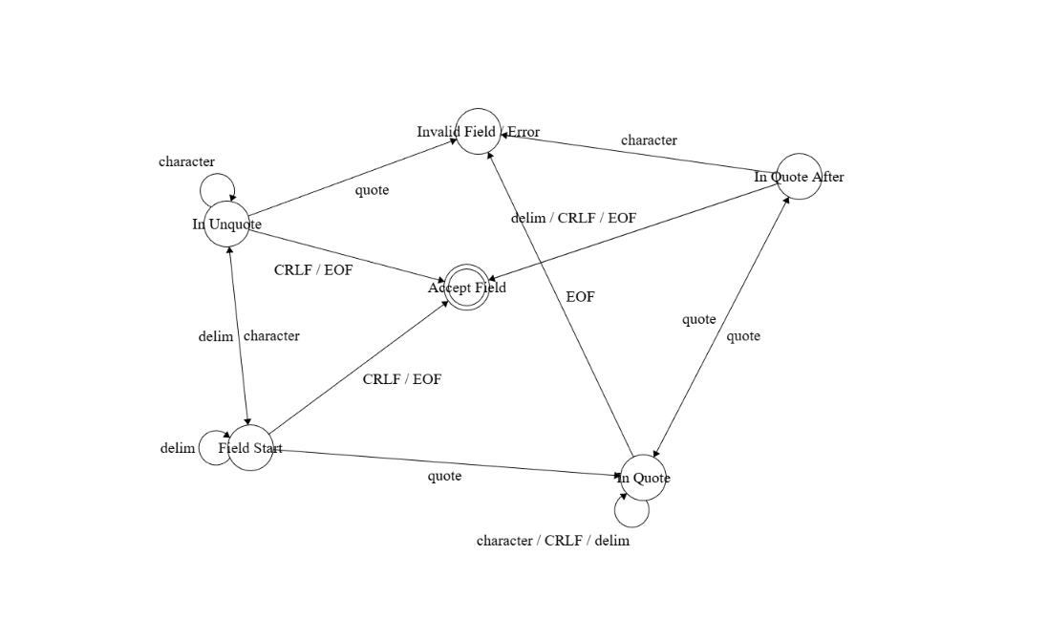

5.2 RFC 4180 CSV Format Specifications
Below lists the format of a CSV file specified by RFC 4180 – which should be followed by the reader interface of this CSV library.
- The first line may be an optional header line. Within the header and each record, there may be one or more fields, separated by commas. Each line should contain the same number of fields throughout the file. Spaces are considered part of a field and should not be ignored.
- Each field may or may not be enclosed in double quotes (however some programs, such as Microsoft Excel, do not use double quotes at all). If fields are not enclosed with double quotes, then double quotes may not appear inside the fields.
- Each record is located on a separate line, delimited by a line break (CRLF).
  - For example: aaa,bb,cc CRLF
- The last record in the file may or may not have an ending line break.
  - For example:
  - aaa,bbb,cc CRLF
  - zzz,yyy
- Fields containing line breaks (CRLF), double quotes, and commas should be enclosed in double-quotes.
  - For example:
  - “aaaa\n”, bb CRLF
- If double-quotes are used to enclose fields, then a double-quote appearing inside a field must be escaped by preceding it with another double quote.
  - For example:
  - “aaa””a”,fff,ddd

